VINOD JAME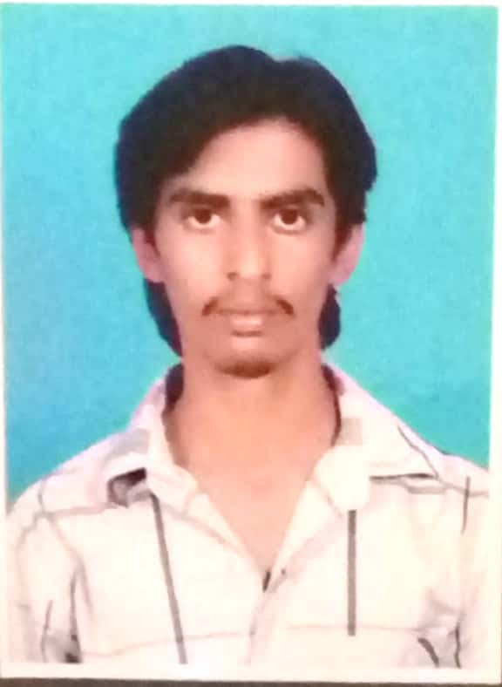S

(+91) 9164953227. 9535698337 –**vinodjames521@gmail.com**

**CAReER OBJECTIVE**

Either directly or indirectly I want to serve my country and to get a job that will bring me respect in the society and finally to succeed in the field of Agriculture.

# ACADEMIC BACKGROUND

|  |  |
| --- | --- |
| **8.27 (CGPA)** **B.Tech (Ag .Engg.)** | 2018-COLLEGE OF AGRICULTURAL ENGINEERING, UAS, RAICHUR. |
| **85.83%**  **PU** | 2014 –ST JOSEPHS PU COLLEGE JYOTHINAGAR CHICKMAGALUR. |
| **87.20%**  **SSLC** | 2012 –ANUGRAHA HIGH SCHOOL SAKALESHAPURA ROAD, AREHALLY,BELUR(TQ),HASSAN(DIST). |

**TRAINING PROGRAMMES UNDERGONE:**

|  |  |
| --- | --- |
| **Duration:**  **6-Weeks** | **INSTITUTE: RURAL AGRICULTURAL ENGINEERING WORK EXPERIENCE THROUGH PLACEMENT IN KALMALA RSK.RAICHUR.**  **Course:**   * Study on socioeconomic status of farmers residing in village. * Study and participate in agricultural activities in farmer’s field. * Visit and study various S&WC structures around village. * Study of Agro processing industries around the village. |

|  |  |
| --- | --- |
| **Duration:**  **1-Month** | **INSTITUTE: SOUTHERN REGION FARM MACHINARY TRAINING AND TESTING INSTITUTE,GARLADDINNE,ANANTAPUR(DIST)**.  **Course:**   * Intensive training on Agricultural Mechanization. |

|  |  |
| --- | --- |
| **Duration:**  **1-Month** | **INSTITUTE: NETAPHIM IRRIGATION PVT LTD.**  **Course:**   * Operation and maintainance of drip irrigation system live project in Hungund taluk. |

# EXTRA CURRICULAR ACTIVITIES

|  |
| --- |
| **Participated in All Indian Agri sports meet-2018 at UAS Bengaluru as University Blue in Volleyball game.** |
| **Participated in special NSS camp held at Katlatkuru village of Raichur district, as a volunteer for the duration of one week** |

**COMPUTER SKILLS**

|  |
| --- |
| **Auto CAD** |
| **MS-Office (MS-Word, MS-Excel and MS-Power point)** |
| **C- Programming** |

**REFERENCES**

|  |  |
| --- | --- |
| **Dr. G V SHRINIVAS REDDY** | Assistant professor , CAE,UAS,Raichur – 9008771441 |
| **Er.Vasanth Kumar G D** | Assistant professor, CAE,UAS,Raichur – 9916882665 |

# perSonal profile

|  |  |
| --- | --- |
| Name  Father’s Name  Date of Birth  Languages Known  Permanent address | VINOD JAMES.  FRANCIS BERNARD.  27-04-1997  Kannada and English.  VINOD JAMES s/o FRANCIS BERNARD,  8th Cross Marianagar(Po)Arakalgud(Tq),  Hassan(Dist). |

**DECLARATION:**

I hereby declare that the above mentioned information provided by me is true to the best of my knowledge.

Place:Raichur signature

Date: (VINOD JAMES)